Consider the following Movie database that you will be writing SQL for, in your first assignment; for simplicity assume that the title of a movie is unique. The length of the movie is its running time in minutes, and net worth of the studio is its monetary value in dollars. The underlined attributes are part of the primary key. Foreign keys are studioName, actorID, movieTitle and rnumber.

Movie (Title, Year, Length, StudioName, ProductionCost)
StarsIn (ActorID, MovieTitle)
Actor (ID, Name, birthdate, Gender)
Studio (Name, Address, Networth)
Student(Rollnumber, Name)
Rating(MovieTitle, Rnumber, rating)

CLO-2
- Give SQL(DDL) statements to create the above schema in the database (in order).
Please ensure that for the rating column of the “rating” table valid values should lie in the range from 1 to 5.

use [movie]

create table Movie
(
Title varchar(150) not null,
Year varchar(4),
Length int,
StudioName varchar(150),
ProductionCost bigint,
constraint MOVIEPK primary key (Title)
);

create table StarsIn
(
ActorID varchar(20) not null,
MovieTitle varchar(150) not null,
constraint STARSINPK primary key (ActorID, MovieTitle),
constraint STARSINFK2 foreign key (MovieTitle) references Movie (Title)
);

create table Actor
(
ID varchar(20) not null,
Name varchar(150),
birthdate date,
Gender varchar(1),
constraint ACTORPK primary key (ID)
);

alter table StarsIn add constraint STARSINFK1 foreign key (ActorID) references Actor (ID)

create table Studio
(
Name varchar(150) not null,
Address varchar(150),
Networth bigint,
constraint STUDIOPK primary key (Name)
);

alter table Movie add constraint MOVIEFK foreign key (StudioName) references Studio (Name)

create table Student
(
Rollnumber varchar(20) not null,
Name varchar(150),
constraint STUDENTPK primary key (Rollnumber)
);

create table Rating
(
MovieTitle varchar(150) not null,
Rnumber varchar(20) not null,
rating int check (rating >=1 and rating <=5)
constraint RATINGPK primary key (MovieTitle, Rnumber),
constraint RATINGFK1 foreign key (MovieTitle) references Movie (Title),
constraint RATINGFK2 foreign key (Rnumber) references Student (Rollnumber)
);

CLO-3
- Give only 6 SQL(DML) statements which are needed to populate the 6 tables (i.e. one row per table) given in the above schema, in order. The data is provided in the in the accompanying f19data_for_assignment1.xls file. Note that you are free to use any data import tool for loading the data provided, in the tables you created in part1. Please ensure that all the data is correctly loaded before proceeding with part 3.

insert into Actor
values ('54761', 'Joaquin Phoenix', '28-Oct-74', 'M')

insert into Studio
values ('DC COMICS', 'Burbank,California', 4000000000)

insert into Student
values ('16L-4450', 'Duaa Ali')

insert into Movie
values ('JOKER', '2019', 120, 'DC COMICS', 55000000)

insert into StarsIn
values ('54761', 'JOKER')

insert into Rating
values ('JOKER', '16L-4450', 2)

CLO-3
- Write an SQL statement to answer each of the following queries:

- Give a list of the actors (both male and female) and their age in years for actors who are more than 60 years old. Your list should be sorted on the basis of actor age and then on the basis of name (if 2 actors have the same age).
select a.Name, datediff(year, a.birthdate, getdate()) Age
from Actor a
where datediff(year, a.birthdate, getdate()) > 60
order by Age, a.Name

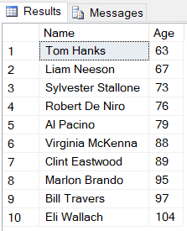

- List all movies made during time period 2000-2010 by studios whose networth is greater than 1 billion.
select m.Title, m.Year, m.StudioName, st.Networth
from Movie m inner join Studio st on m.StudioName = st.Name
where (m.Year between '2000' and '2010') and (st.Networth > 1000000000)

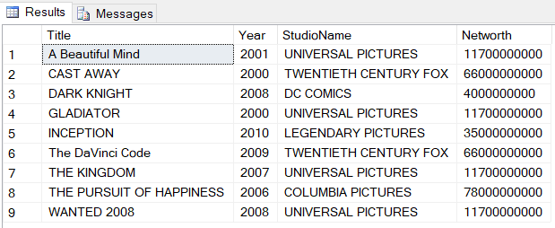
- List all actors (both male and female) born before 01-jan-1960 along with the movies they have starred in. Actor name should be displayed even if s/he hasn’t worked in a movie. Your report should be sorted on the basis of movie title.
select a.Name, si.MovieTitle
from Actor a left outer join StarsIn si on a.ID = si.ActorID
where a.birthdate < '1960-01-01'
order by si.MovieTitle

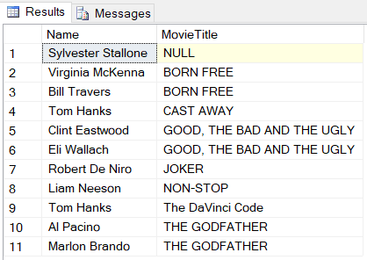
- Find the minimum, maximum and average rating of movies made by studios based in California and which have produced at least 15 movies.

select m.Title, min(r.rating) MinRating, max(r.rating) MaxRating, avg(r.rating) AvgRating
from Rating r inner join Movie m on r.MovieTitle = m.Title
inner join Studio st on m.StudioName = st.Name
where (st.Address like '%California%') and m.StudioName in
(
select m.StudioName
from Movie m
group by m.StudioName
having count(m.StudioName) >= 15
)
group by m.Title



- List those actor (both male and female) pairs who have worked together in the same movie along with movie name.

select a1.Name A1, a2.Name A2, si.MovieTitle
from Actor a1, Actor a2, StarsIn si
where a1.ID = si.ActorID
group by si.MovieTitle, a1.Name, a2.Name, a1.ID, a2.ID
having si.MovieTitle in
(
select s.MovieTitle
from StarsIn s
where a2.ID = s.ActorID and a2.Name > a1.Name
)
order by si.MovieTitle

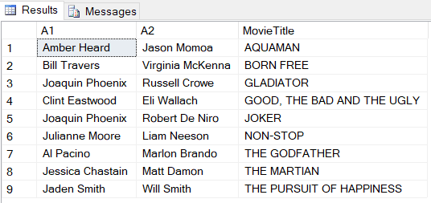

- Find the student(s) who has not rated any movie.

select std.Name, std.Rollnumber
from Student std
where std.Rollnumber not in
(
select r.Rnumber
from rating r
)

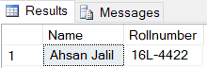

- Find the student(s) who has rated all the movies.

select std.Name, std.Rollnumber
from Rating r inner join Student std on r.Rnumber = std.Rollnumber
group by std.Name, std.Rollnumber
having count(*) =
(
select count(m.Title)
from Movie m
)

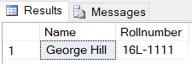

- Find the movie with the second highest production cost.

select m.Title, m.ProductionCost
from Movie m
where m.ProductionCost =
(
select max(m.ProductionCost)
from Movie m
where m.ProductionCost <>
(
select max(m.ProductionCost)
from Movie m
)
)

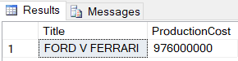

- Find the movie which has been rated by the maximum number of students.

select r.MovieTitle
from Rating r
group by r.MovieTitle
having count(*) =
(
select max(r1.RatingCount) count
from
(
select r2.MovieTitle, count(*) RatingCount
from Rating r2
group by r2.MovieTitle
) r1
)

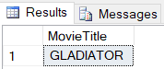

- Find those actor(s) who have worked in more movies than all actresses.

select a.Name, si.ActorID, count(*) MovieCount
from Actor a inner join StarsIn si on a.ID = si.ActorID
where a.Gender = 'M'
group by a.Name, si.ActorID
having count(*) >
(
select max(amc.ActressMovieCount) MaxActressMovieCount
from
(
select count(*) ActressMovieCount
from Actor a inner join StarsIn si on a.ID = si.ActorID
where a.Gender = 'F'
group by si.ActorID
) amc
)

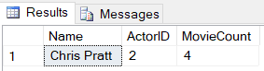

- Display the name of actors who have appeared in any movie made by “UNIVERSAL PICTURES” but not in any movie made by “TWENTIETH CENTURY FOX”.

select distinct a.Name
from Studio st inner join Movie m on st.Name = m.StudioName
inner join StarsIn si on m.Title = si.MovieTitle
inner join Actor a on si.ActorID = a.ID
where (m.StudioName = 'UNIVERSAL PICTURES') and m.StudioName <> all
(
select distinct a.Name
from Studio st inner join Movie m on st.Name = m.StudioName
inner join StarsIn si on m.Title = si.MovieTitle
inner join Actor a on si.ActorID = a.ID
where m.StudioName = 'TWENTIETH CENTURY FOX'
)

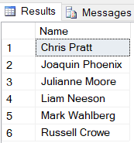

- Display the name of all student(s) who have rated both “GLADIATOR” and “BORN FREE”

select std.Name
from Student std inner join Rating r on std.Rollnumber = r.Rnumber
where r.MovieTitle = 'GLADIATOR'
intersect
select std.Name
from Student std inner join Rating r on std.Rollnumber = r.Rnumber
where r.MovieTitle = 'BORN FREE'

